Retail Sales Analysis Using Power Bi
Introduction
This project focuses on analyzing retail customer shopping data to understand sales performance, customer purchasing behavior, and revenue distribution across different product categories and shopping malls. The objective of the project is to transform raw transaction data into meaningful insights using Power BI.

Tools Used
- Power BI
- Power Query
- DAX
- Data Modeling

Data Attributes:
The dataset contains customer transaction records with the following attributes:
- Customer ID
- Age
- Gender
- Product Category
- Shopping Mall
- Payment Method
- Quantity Purchased
- Purchase Date
- Price

Data Preparation
The dataset was cleaned and transformed using Power Query.
Steps performed:
- Removed duplicate values
- Converted data types where necessary
- Created multiple tables for better data modeling

Data Modeling
The dataset was divided into multiple tables to demonstrate data modeling techniques.
Relationships were created between the tables using common fields such as:
- Customer ID
- Product Category

DAX Measures
Several measures were created using DAX to calculate key metrics:
- Total Revenue
Total Revenue = SUM(Sales[price])
- Total Orders
Total Orders = DISTINCTCOUNT(Sales[invoice_no])
- Average Revenue per Customer
Avg Revenue per Customer =
DIVIDE([Total Revenue], DISTINCTCOUNT(Sales[customer_id]))

Dashboard Visualizations
The Power BI dashboard includes multiple visualizations to analyze the data:
- KPI cards displaying total revenue, total orders, and quantity sold
- Revenue distribution across product categories
- Sales performance across shopping malls
- Payment method analysis
- revenue trend analysis over time
- Interactive slicers for filtering data

Key Insights
- The dashboard shows a total revenue of approximately 251.51M generated from around 99K orders, indicating strong overall sales activity.
- A total of 299K products were sold, which suggests that customers frequently purchase multiple items in a single transaction.
- The average order value is approximately 2.53K, indicating that each customer transaction contributes a moderate amount to total revenue.
- Clothing is the highest revenue-generating category, making it the most dominant product segment in the retail dataset.
- Categories such as Technology and Shoes also contribute significantly to total revenue, showing strong customer demand for these products.
- Books and Souvenirs generate comparatively lower revenue, suggesting they are purchased less frequently compared to other categories.
- Cash is the most commonly used payment method, contributing the largest share of revenue, followed by credit card and debit card transactions.
- Mall-wise revenue analysis shows that Mall of Istanbul generates the highest revenue, followed by Kanyon and Metrocity.
- The monthly revenue trend shows fluctuations across months and years, suggesting possible seasonal variations in customer purchasing behavior.
- A noticeable decline in revenue appears in 2023, which may indicate incomplete yearly data or changes in consumer spending patterns.

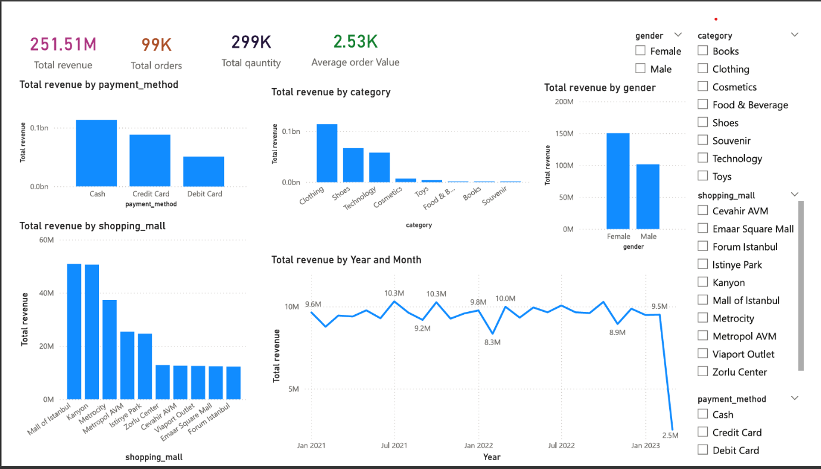

Conclusion
This project demonstrates how retail transaction data can be effectively analyzed using Power BI to uncover meaningful business insights. Through data cleaning, data modeling, and the use of DAX measures, an interactive dashboard was developed to analyze sales performance across product categories, shopping malls, and payment methods. The analysis shows that the Clothing category contributes the highest share of revenue, while cash remains the most preferred payment method among customers. Additionally, sales performance varies across different shopping malls, with Mall of Istanbul generating the highest revenue. The sales trend also reveals fluctuations across months and a noticeable decline in 2023, which may indicate incomplete data or changes in consumer purchasing patterns. Overall, the dashboard provides a clear overview of retail performance and demonstrates how data visualization can support better understanding of customer behavior and sales trends, enabling more informed business decision-making.

